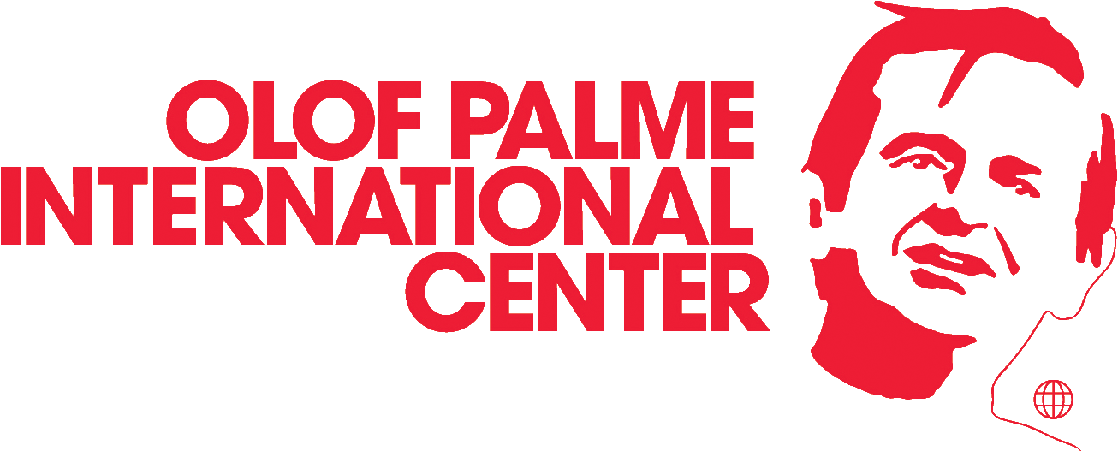
Project number:
Reporting year:
Date of submission of report:

Western balkan programme - NARRATIVE REport

This template is for yearly reporting on activities and results. It has been developed to collect information about many different aspects of your work and will provide the Palme Center with necessary information for reporting to Sida.
Instructions for reporting
An electronic copy of the narrative report shall be sent by e-mail in word-format to your programme officer at Palme Center.
Final date for submission of the annual report is:
- February 1st (the following year)

Necessary documents for reporting
The project application for the referred year is the basic document for this report.
- Project application including budget.
- Results matrix of the project.
- Risk matrix for the project.
- Other relevant protocols, evaluations and documents with project information from this project period, as dialogue meeting notes.
We recommend that you invest time in discussions within the organization and other relevant stakeholders to gather all achievements and lessons learnt for the period. Focus on the following thematic areas:
- Project activities that were carried out during the year and explanation of any deviations from the original plan.
- Results achieved from project activities carried out this year (use the results matrix)
- Narrative explanations regarding financial deviations from plan (if any)

A short results vocabulary
In all reporting the Palme Center apply the commonly used results vocabulary of results achieved on output- outcome and impact levels. Here is a short explanation of what these words mean:
Impact level: Long-term effects, more permanent and on a higher societal level. For example, that an organisation or the target group has increased its influence in society and has contributed to positive change for development.

Outcome level: medium-term results in terms of changes in behaviour and relations of the people that the project relates to. Changes in their ability to participate in society, access to human rights, power and influence, etc.

Output level: Concrete short-term results of project activities. For example increased knowledge or an increased ability to apply knowledge following a training course.

PROJECT AND CONTACT information

About the project
Project title:
Project number:
Project country:
Year that the project started:

About the implementing organization in the project country
Organisation:
Project manager:
Telephone: |  | E-mail:
Financial manager:
Telephone: |  | E-mail:
Other member/s:
Telephone: |  | E-mail:

Results

Fill in the LFA matrix below:
Copy the project objectives and the intermediate objectives from the LFA-matrix in the approved application. | Copy the indicators from the LFA-matrix in the approved application. | State the progress of each indicator. | How was the results measured (base this on the planned means of verification stated in the application)?
Project Objective | Indicators | Progress of indicators | Means of verification
Intermediate Objective 1 | Indicators | Progress of indicators | Means of verification
Intermediate Objective 2 | Indicators | Progress of indicators | Means of verification
Intermediate Objective 3 | Indicators | Progress of indicators | Means of verification

1 Discussion on PROJECT Results
Discuss the result matrix and describe the progress using the indicators connected to each objective.
Project objective:

Intermediate objective 1:

Intermediate objective 2:

Intermediate objective 3:

1.1 Please describe which positive changes/results you think that this project has contributed to for the target group. Have there been any unexpected positive or negative results?
Please write your description here:

1.2 Describe how the project cooperation has contributed to an internal development of your organisation (e.g. increased capacity of your staff, better working methods, increased internal democracy e.g. through the development of transparent steering documents or democratic mechanisms for decision making, increased gender equality within the organisation, developed processes and routines etc).
Please write your description here:

  - Describe how the project has contributed to increased external cooperation/networking with other organisations and/or relevant stakeholders within the framework of this project during the year.
Please write your description here:

  - Describe the activities and methods used in the project that you think have been most effective for achieving the project objectives - and why you think they worked out well.
Please write your description here:

  - Describe how you worked to include the target group and other relevant actors in the planning, implementation and evaluation of the project during the project. Include a brief description of specific experiences of difficulties or success, if there are any.
Please write your description here:

  - Have there been any particular difficulties in your work to reach the target group? Have you reached the target group to the extent that you wanted? If not -why? Difficulties or success stories you can share regarding this?
Please write your answer here:

  - Describe how the results of your project can be sustainable (continue after your project co-operation has ended)? For example changes in legislation, increased awareness among target groups.
Please write your description here:

  - Describe in what way the Palme Center has supported/contributed to the planning, implementation and evaluation of the project. What has been the most important contribution from the Palme Center during the project period? Any recommendations for the future?
Please write your answer here:

  - Looking back at last year – what are your overall conclusions and what are the most important lessons learnt? What have been most important success factors and obstacles according to your view? What experience would you like to share with the Palme Center and other organisations currently setting up similar projects?
Please write your answer here:

2. In relation to the Results Assessment Framework (RAF) – please refer to the progress markers/indicators most relevant for your main target group (citizens, civil society sector, officials at local level/national level)

Citizen engagement (relating to participation in your activities/articulation of concerns/exercising influence)
Answer here:

Civil society sector (relating to civil society’s role, capacity, status and legitimacy)
Answer here:

Officials at local level (relating to accountability, transparency, availability, sharing of information, interest in civil society, positive decisions or revised policy)
Answer here:

Officials at national level (relating to accountability, transparency, availability, sharing of information, interest in civil society, positive decisions or revised policy)
Answer here:

3.1 Project Activities
Statistics for activities completed during project year (add rows if necessary).
Type of activity | No. of activities | Type of target group | No. of women | No. of men | Total no. of participants
1.
2.
3.
4.
5.
6.
7.
8.
9.
TOTAL NUMBER REACHED

Assess the activities that you have listed in the table above: where they successful or not? In what way? How did they contribute to progress in relation to project objectives? Add more activities if necessary:
Activity 1:

Activity 2:

Activity 3:

Activity 4:

Activity 5:

Activity 6:

Did you carry out all planned activities? If no; explain the deviations and how it has affected the project and the fulfilment of objectives.
Answer here:

3.2 Cross-Cutting issues
Describe how you have worked for gender equality and non-discrimination within your project. What have been the main successes and difficulties? What results do you see of this work? Any examples/success stories you can share? (For example changes in power balances, responsibilities for men and women within the organization or target group, participation of discriminated groups etc).
Answer here:

Has the project had any positive or negative environmental consequences?
Answer here:

How do you limit the risk of corruption and/or deal with it?
Answer here:

3.3 Risk Analysis
Assess the risk analysis made in the application. Did it help us avoid certain risks? Have there been any unforeseen risks that affected the project and the fulfilment of objectives?
Answer here:

3.4 Budget, Administration and Audit
If there have been any deviations in the financial reporting from the planned budget – please list the deviations one by one below and explain the reason for the deviation.
Please answer here:

Did the administrative aspects of the project work satisfactory (such as funds transfers, bookkeeping, financial reporting and audit)?
Answer here:

Appendix: Check-list for reporting
Follow the steps of the check-list carefully. If any of these steps/documents are missing, your narrative and financial reporting is not complete. Please make sure to tick all the boxes before sending your report to the Palme Center.
Check list for implementing organisation in the project/program country
The Narrative report template has been filled in.
The Expenditure Specification has been based on the approved budget for the financial year of the report, and is signed by an authorized signatory in the organisation as well as by the auditor.
The form Accounts in Local Currency has been filled in and is attached.
The Auditor Report according to ISA 805 (according to the Palme Center audit instruction), is attached and has been signed by the auditor.
The Management Letter (according to the Palme Center audit instruction), is attached and has been signed by the auditor.
A Certificate verifying the title of the auditor (CPA, CA, or equivalent according to national law) is attached.

If you have more intermediate objectives, please add them.

