DESIGN A TRAINING FOR EFFICIENT LEARNING
1. TARGET GROUP
Who is the training for?
2. DESIRED BEHAVIOUR CHANGE
It is useful to keep in mind that only behaviour changes the world.
An increase in knowledge or a change in attitude alone will not change anything, but knowledge and attitudes make it more likely for desired behaviours to manifest.
Which real life behaviour do you wish to support with this training?
3. LEARNING OBJECTIVES  Verbs to use:  Define / Explain / Identify …  Analyse / Plan / Draft / Design …  Propose / Recommend / Advocate for…  Consult Bloom’s taxonomy if needed! (Bottom of this doc) | After active engagement in the workshop, participants are able to:
4. MY SALES SPEECH
Write down a few key points on why and how knowing what you will teach will enrich the participants’ lives. What are the benefits of (copy learning objectives here, eg being able to analyse, draft and plan xxx). What are the negative implications of not doing it? Keep in mind that adults tent to learn only what they find relevant. Sell your session!
5. CENTRAL PARTICIPANT ACTIVITY
Whatever you list as learning objectives equals what participants will train on. Train, and also reflect and discuss.
If you expect participants to draft or negotiate = allow time for practicing drafting and negotiating.
Consider the difference in time needed to “define” vs “analyse”.
6. THEORETICAL INPUT
What new theory or concept will participants benefit from knowing in order to make it most likely for them to change their current practice? Limit your theoretical input to max 15 minutes in one go.
7. ADDITIONAL PARTICIPANT ACTIVITY
Mark an activity you are brave enough to try. As you observe/listen to participants you also get proof of their learning.
- A guessing game: Participants view a question (on a powerpoint slide), consider the listed options, and give it a try. You then reveal the right answer.
- A quiz: Similar to the above, but with a handout. You can design your entire presentation as the right answers to the quiz questions.
- A buzz group in which you ask participants to discuss a given question or summarize their key takeaways so far to each other. Trying to rephrase what we have heard before requires conscious effort. Mastering that effort in the classroom makes us more likely to be able to reproduce it afterwards, else insights tend to be forgotten within hours or days.
- Sociometer / role play / four corners / gallery walk / other …
8. EVALUATING LEARNING  How will you know if the learning objectives were reached?  Remember the focus is on learning and preferably also changed behaviours, rather than reactions to the training itself (premises, trainers).  On what level will you evaluate learning? Learning objectives and/or changed behaviours?  What methods will you use?  - Baseline and post-course testing of knowledge  - Self-assessment of learning (written, oral)  - Games like taboo/speed dating where participants explain key concepts themselves  - Observing participants perform the learning objective  - Ask a third party in participants’ organisations if there has been any changed behaviour?  - Other  When is the best time to evaluate these things? During or directly after the course, or a while later?  (See the four levels at which you can evaluate the training in Kirkpatrick’s staircase at the bottom of this doc) | Level:  How?  When?
9. SUMMARIZING IT ALL & IDENTIFYING NEXT STEPS
Workshops that are of real value lead to some changed behaviours. These behaviours need to take place as soon as possible after the workshop. Several weeks later, the likelihood is dramatically decreased as other issues have become more important.
Plan time here for your audience to summarize their key take-aways and to identify their very next step and when they will do it.

Useful models when planning your training
Bloom’s taxonomy—use as inspiration when setting learning objectives

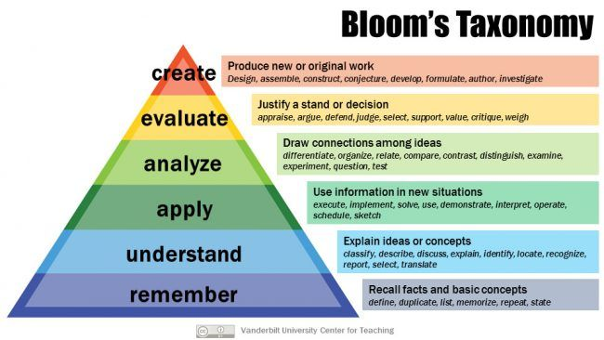

Kirkpatrick’s staircase—use as guidance when deciding which level to evaluate the results of the training on. (Level 2 should always be measured, as a minimum.)
